

|  |
| --- |
| Capstone Project Report |
|  |
| February 7  Authored by: Sneha Devadas |

# Identifying an Ideal Location for a Supplement Shop in Manhattan

Introduction

Manhattan, known regionally as **the City** and the urban core of the New York metropolitan area, is the most densely populated of the five boroughs of New York City. Manhattan has been described as the cultural, financial, media, and entertainment capital of the world, and the borough hosts the United Nations Headquarters. Anchored by Wall Street in the Financial District of Lower Manhattan, New York City has been called both the most economically powerful city and the leading financial center of the world. Manhattan real estate has since become among the most expensive in the world, with the value of Manhattan Island, including real estate, estimated to exceed US$3 trillion in 2013; median residential property sale prices in Manhattan approximated US$1,600 per square foot ($17,000/m2) as of 2018, with Fifth Avenue in Midtown Manhattan commanding the highest retail rents in the world, at US$3,000 per square foot ($32,000/m2) per year in 2017.

To setup and run a business entity in such location requires a great deal of consideration and deliberation. Among important factors such as financial, operational and legal considerations, the location of the proposed business venture plays a very important role. It is so powerful a factor that it can make or break the business. We need to identify such a location that it effectively addresses the gap in demand. In other words, we need to identify an area which has a lot of market potential waiting to be tapped. One way to identify this is by analyzing the presence and popularity of such business ventures in the proposed area versus the demand.

**Business Problem/Problem Statement**

*Identify a location for setting up a new Supplement Store in one of the neighborhoods in Manhattan, which may help to maximize the sales.*

**Stakeholder**

An individual or a partnership interested to setup a Supplement Shop in the neighborhoods of Manhattan.

**Data**

To address the business problem defined in the previous section, we need the following data:

* Name of all the neighborhoods in Manhattan along with the geographical coordinates (latitude and longitude).
* List of popular venues in each of these neighborhoods.

“newyork_data.json” file available in the following link (<https://cf-courses-data.s3.us.cloud-object-storage.appdomain.cloud/IBMDeveloperSkillsNetwork-DS0701EN-SkillsNetwork/labs/newyork_data.json>) contains the a dataset that contains the 5 boroughs and the neighborhoods that exist in each borough in New York , where Manhattan is one borough, as well as the latitude and longitude coordinates of each neighborhood.

For example, below is snapshot of the data extracted from “newyork_data.json” file.

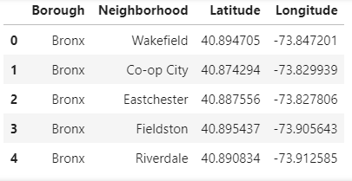

This dataset is cleaned and processed to retrieve data of the neighborhoods in Manhattan alone.

List of popular venues in each of the neighborhood is obtained with the help of Foursquare API. The data is obtained in the form of a json file, which is then processed to retrieve the desired information i.e., the venue name, category to which it belongs, the latitude and longitude of the venue.

For example, the information extracted from the response.json file for the neighborhood Stuyvesant Town in Manhattan is as follows.

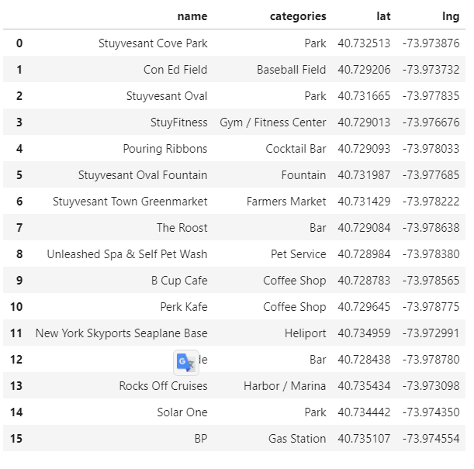

These datasets are then used for segmenting and clustering the neighborhoods in Manhattan. Further analysis of these clusters will help us to identify the neighborhood or list of neighborhoods which are promising.